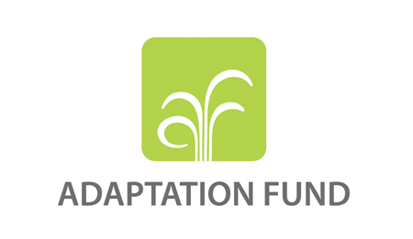 

**Adaptation Fund Thematic Event: Empowering the most vulnerable, women, youth, elderly, indigenous populations and incorporating local and traditional knowledge**

**Theme:** *Learning from indigenous and local people’s knowledges and expertise in adaptation*

During the session AF National Implementing Entities (NIE)s discuss findings from projects that benefit and empower the most vulnerable communities such as women, youth, the elderly, and indigenous populations, and incorporate local and traditional knowledge.

**Organization and moderation**

The session will be moderated by AF secretariat who will set the stage from a knowledge and learning perspective and will link it to adaptation. This will be followed by 2-3 NIE representatives and an NGO representative who will have the opportunity to speak about the importance of incorporating the knowledge of local and indigenous peoples in climate adaptation interventions from their own country perspective and the from their experience of implementing AF-funded projects.

The four presentations will be short, maximum 10 minutes each, to focus more on discussion. There will be room for reflection and discussion in between.

The session will conclude with a broader discussion in the end, reaching back to the key questions and shared experiences from the start of the session, with the aim to reflect back on the presentations and get more perspectives and thoughts from the audience.

**Target audience**: climate adaptation and development practitioners, academia, knowledge institutions, governments

**Discussants**: AF secretariat, implementing entities of the Adaptation Fund, AF NGO network representative

**Estimated time**: 1-1.5 hours

**Remote participation***:* In-person participation strongly preferred, but it would

be nice to have the option to connect with a remote speaker